# Requirement Document

## Project Overview

* Objective: Build a modern real estate second hand marketplace with JWT authentication an and Redux Toolkit.
* Target Audience: Users interested in buying or selling used products.

## Functional Requirements

* Authentication:
  + Implement JWT authentication for secure user login and registration.
  + Include user profile management features (update, delete, sign-out).
* Listings:
  + Users can create new product listings with details such as images, description, price, etc.
  + Implement CRUD functionality for listings (Create, Read, Update, Delete).
  + Admin approves the listing of the product and its information.
* User Interaction:
  + Seller and Buyer can contact each other using their contact information.
  + Implement a messaging or notification system for communication between users.
* Frontend:
  + Use React.js for the frontend development.
  + Implement a responsive and user-friendly design with Tailwind CSS.

## Non-Functional Requirements

* Performance: Ensure the application is responsive and can handle a reasonable number of concurrent users.
* Security: Implement secure authentication and authorization to protect user data.

## Technology Stack

## -BackEnd

* + Node.js as the runtime environment for the backend
  + Express.js as the backend framework
  + MongoDB for the database
  + Mongoose as the ODM (Object Data Modeling) library for MongoDB
  + Axios for api calls

## -FrontEnd

* + React.js for the frontend
  + Tailwind CSS and antd for styling
  + Redux Toolkit for state manageme

## -Authentication

* + JWT for authentication and authorization

## Deployment

* Deploy the application to a hosting service (e.g., Vercel).

# Design Document

## System Architecture

* Client-Server architecture with React.js as the frontend and Express.js/Node.js as the backend.
* Use Redux Toolkit for state management.

## Database Schema

* User table: id, username, email, password, etc.

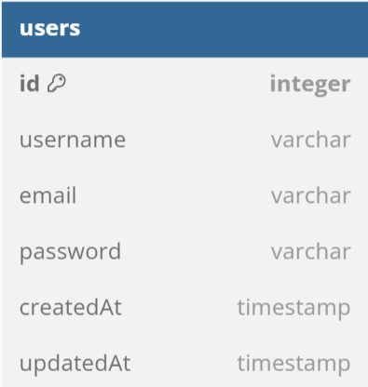

* Listing table: id, title, description, images, price, contact details, etc.

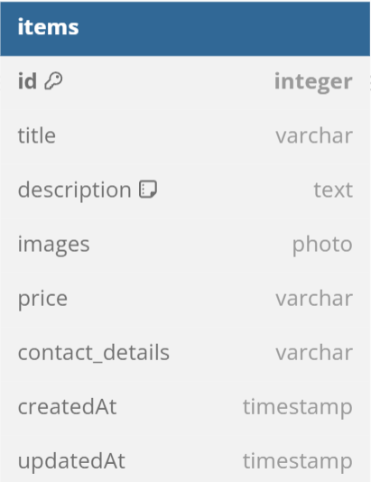

* Bidding table: id, amount, message, contact details, etc.

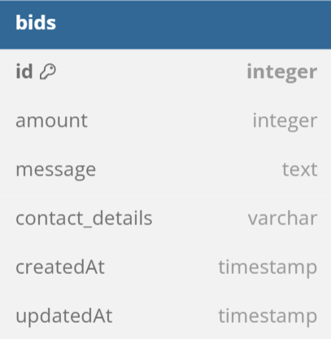

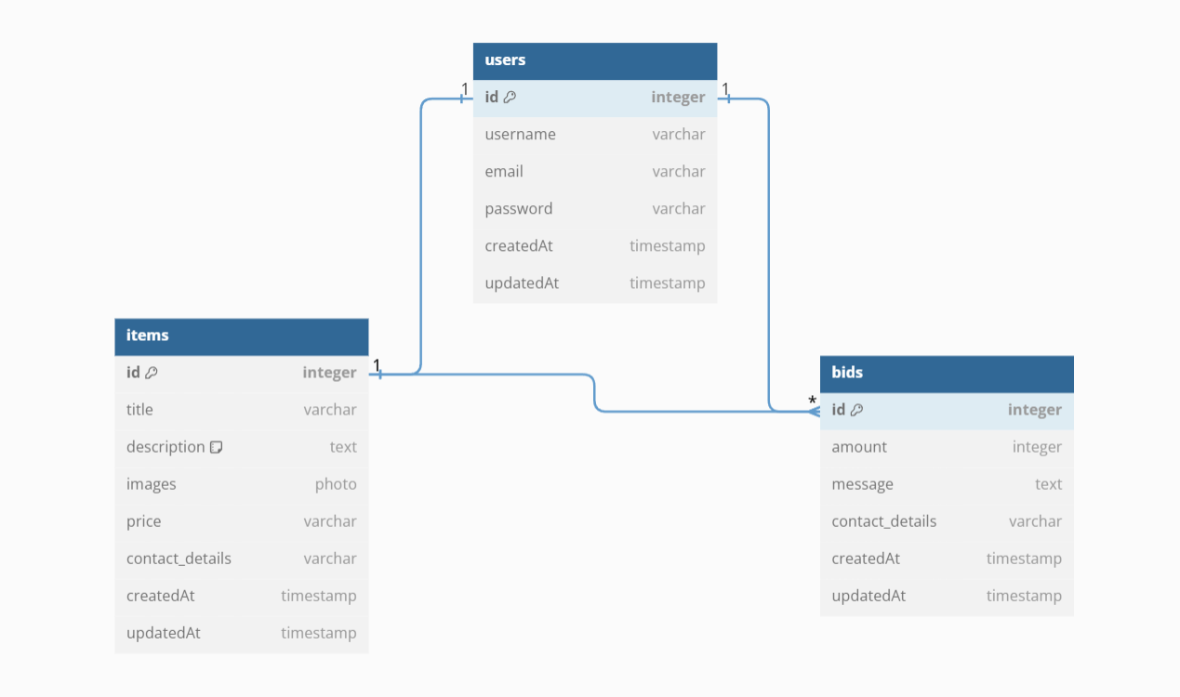

## Authentication Flow

* User registration and login with JWT tokens.
* Secure routes and API endpoints requiring valid JWT tokens.

## User Interface Design

* Design responsive and intuitive UI using React.js, Tailwind CSS and antd.
* Include pages for listings, user profile, search, filter, etc.

## API Endpoints

* Define API endpoints for user authentication, CRUD operations on listings, bidding,

etc.

## Error Handling

* Implement a consistent error-handling mechanism for API requests and form submissions.

## Deployment Strategy Testing

* Define testing strategies for both frontend and backend components.

## Scalability

* Consider potential future scalability requirements and design the system to handle

increased user loads.